**Exercise 2 - Assertion in JUnit**

**Objective:**

To understand and implement various types of assertions provided by the JUnit 5 testing framework.

**Steps Followed:**

1. Created a new test class named AssertionTest.java inside src/test/java.
2. Used JUnit’s assertion methods to compare expected and actual results.
3. Verified if different types of assertions pass correctly.

**Java Code:**

import org.junit.jupiter.api.Test;

import static org.junit.jupiter.api.Assertions.*;

public class AssertionTest {

@Test

public void testEquality() {

assertEquals(10, 5 + 5);

}

@Test

public void testTrueCondition() {

assertTrue(10 > 1);

}

@Test

public void testFalseCondition() {

assertFalse(5 > 10);

}

@Test

public void testArrayEquals() {

int[] expected = {1, 2, 3};

int[] actual = {1, 2, 3};

assertArrayEquals(expected, actual);

}

}

**Output:**

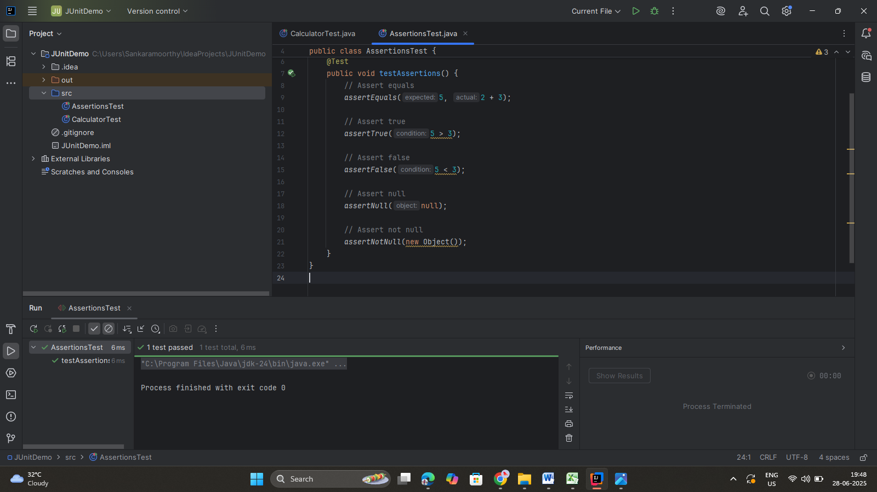

**Tools Used:**

* IntelliJ IDEA
* JUnit 5 (via Maven)